JUNE 11, 2017

# GROUP PROJECT

GROUP 3

NITHESH, NANA, ABYADH, AND DEBORAH

UNIVERSITY OF WEST LONDON

## ADMINISTRATOR BUSINESS PROCESS

The administrator creates users and sends an invitation to Employers and Students to register to the portal. He then reviewed internship listings posted by employers and send a confirmation to the employer. He goes on to send the available internship listings to students for them to make formal application and forward students CV to the employer. Also, the administrator tracks the application process and receives a notification of feedback about students from the employer.

## ADMINISTRATOR BUSINESS MODEL

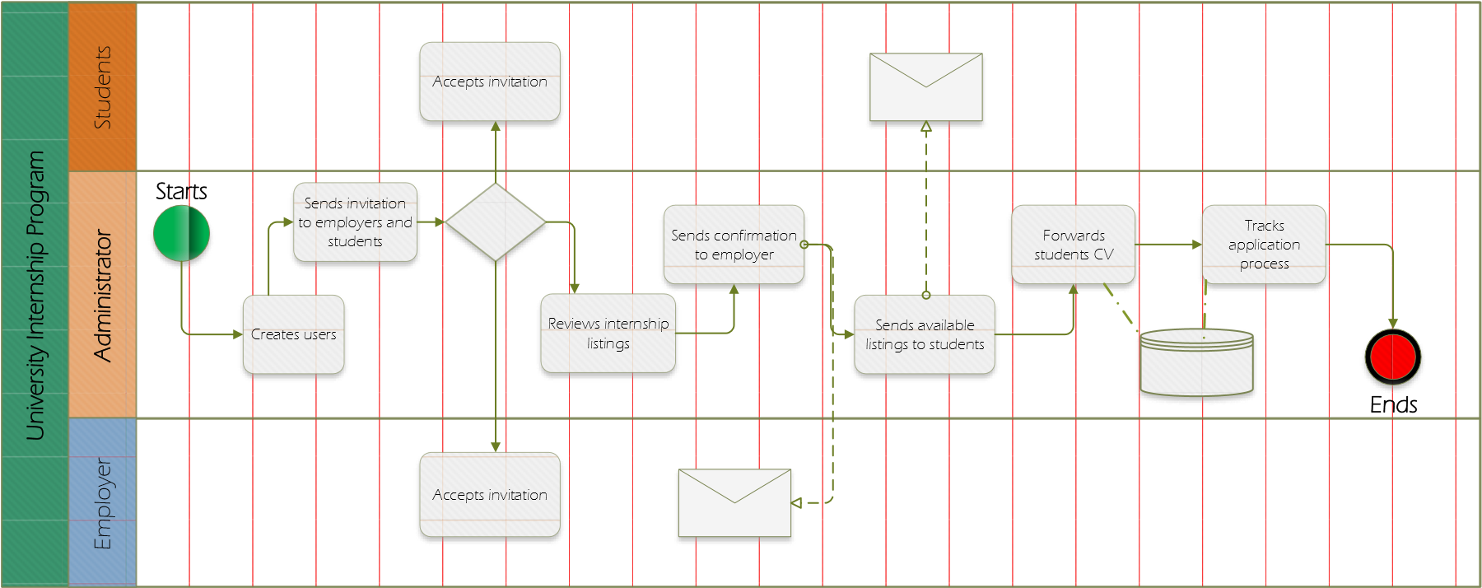

## EMPLOYER BUSINESS PROCESS

The employer accepts an invitation from the administrator to register to the portal. Employer post internship listings on the portal and waits for the administrator to review the listing and invite students to make applications. The system allows the employer to select a student and track student’s internship listing progress. If the student has completed the internship, the employer then provides a feedback. If the student has not done the internship, the employer goes back to the internship listing and select a different student and repeat the process.

## EMPLOYER MODEL

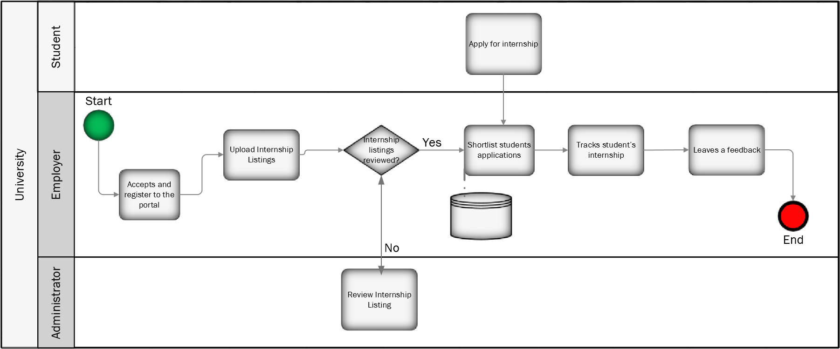

### STUDENT APPLYING

Upload CV to the system, after uploading the CV then log into the system to manage their CV. Search for suitable internships, find an internship then request for that internship. Administrator sends student internship application. Apply for Internship and send the application.

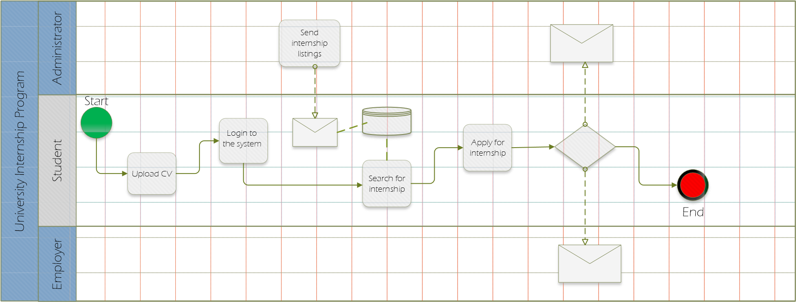

### STUDENT ACCEPTING

Receives a yes confirmation from the administrator based on application. If yes, the application is approved. The student accepts the internship or declines. The student accepts the internship then attends. Complete the internship and provide feedback and stores it on the system.

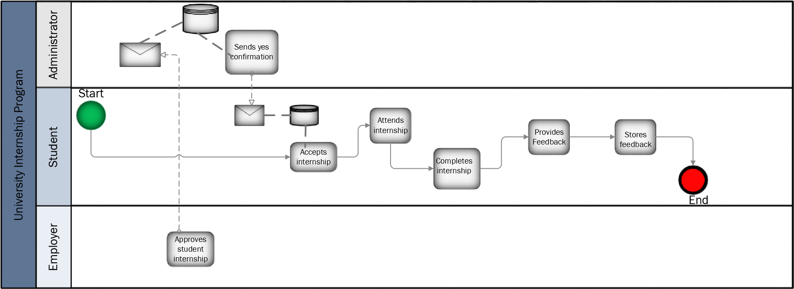

## User Story

|  |  |  |  |  |  |  |
| --- | --- | --- | --- | --- | --- | --- |
| **User**  **Story**  **ID** | **Theme** | **As a/ an** *<type of user>* | ***I want to*** *<perform some task>* | ***so that I can*** *<achieve some goal>* | **Priority** | **Status** |
| **AD01** | Functional | Administrator | Send user registration email from the system. | Create user in the system i.e. Students and Employer’s Recruiters |  |  |
| **AD02** | Functional | Administrator | Receive email notification up on user registration. | Verify all the user types. |  |  |
| **AD03** | Functional | Administrator | Review employers profile and job posted | Verify the profile and activate the job requisitions to the portal. |  |  |
| **AD04** | Functional | Administrator | Review Student’s profile | Verify the right batch students are registered and completed all sections of the online application. |  |  |
| **AD05** | Functional | Administrator | Delete/deactivate user from the system | Delete the user from the system and deactivate account from the portal. |  |  |
| **AD06** | Functional | Administrator | Add/ update the job category field | Adding/updating the correct job category can help employer post the job to the correct category and the student applying for the jobs are auto selected based on the subject specialities and job category. |  |  |
| **AD07** | Functional | Administrator | Review student that have applied for the job and forward the application to the employer. | Verify the students that have applied for the correct job based on the field of their studies and interest. |  |  |
| **AD08** | Functional | Administrator | View and receive notification for changes made to the job. | Review the changes are made to the job's when employer recruiter update/ change/freeze job published. |  |  |

|  |  |  |  |  |  |  |
| --- | --- | --- | --- | --- | --- | --- |
| **AD09** | Functional | Administrator | View and receive notification about students who fail the interview or deselected students. | Track all the dispositioned students if not successful also students who have not attended the scheduled interview. |  |  |
| **AD10** | Functional | Administrator | Bulk / individual email communication with the students | Email communication with the students for any communications during and after the internship process. |  |  |
| **AD11** | Functional | Administrator | Email communication function to communicate with employer | Email communication with the registered employer during the process. |  |  |
| **AD12** | Functional | Administrator | Report functional to check jobs and application process | Run reports to check opened jobs and status of the students applied |  |  |
| **AD13** | Functional | Administrator | View all students in the on-boarding stage | Check all the students who are in the on-boarding process |  |  |
| **AD14** | Functional | Administrator | Send notification to employer to provide feedback | Notify employer to provide feedback for all the students attending the internship. |  |  |
| **EM01** | Functional | Employer- Recruiter | Receive link to register my company profile and add Jobs | Add my company details and job |  |  |
| **EM02** | Functional | Employer- Recruiter | Confirmation of the registration | Get email notification confirming the registration and User ID and Password provided to log in to update the job details. |  |  |
| **EM03** | Functional | Employer- Recruiter | Log in to the portal using username and password, also to update profile. | Check my credentials are valid and update the company profile |  |  |
| **EM04** | Functional | Employer- Recruiter | Create a job requisitions application. | Post all the job that are open to my organisation |  |  |
| **EM05** | Functional | Employer- Recruiter | Change a Job Requisition | Change a job requisition. |  |  |
| **EM06** | Functional | Employer- Recruiter | Close a Job Requisition | Close the job requisition as required |  |  |

|  |  |  |  |  |  |  |
| --- | --- | --- | --- | --- | --- | --- |
| **EM07** | Functional | Employer- Recruiter | Freeze a Job Requisition | Freeze a job requisition as required |  |  |
| **EM08** | Functional | Employer- Recruiter | Update a Job Post | Update a job post as required |  |  |
| **EM09** | Functional | Employer- Recruiter | Review Applicant | Verify that the Applicant is reviewed in the Job Application Search all applied students |  |  |
| **EM10** | Functional | Employer- Recruiter | Screen Applicant for Interview | Verify that the Applicant has been screened and interviews are set up for the Applicant. Verify that possible dispositions are considered. |  |  |
| **EM11** | Functional | Employer- Recruiter | Assess student Candidate | Verify that the Applicant has been assessed through the Assess Candidate company process.  Verify that possible dispositions are considered |  |  |
| **EM12** | Functional | Employer- Recruiter | Interview Student Applicant | Verify that the Applicant has been interviewed.  Verify that all possible dispositions are considered. |  |  |
| **EM13** | Functional | Employer- Recruiter | Conduct a Reference Check | Verify that the Applicant has filtered through the Reference Check when required. |  |  |
| **EM14** | Functional | Employer- Recruiter | Make Applicant an Offer | Verify that the Applicant accepts/refuse an offer. |  |  |
| **EM15** | Functional | Employer- Recruiter | Student Candidate performance update on the system. | Provide feedback during the internship time. |  |  |
| **ST01** | Functional | Students | Register my profile and add my CV to the system | Register my details and upload my CV. |  |  |

|  |  |  |  |  |  |  |
| --- | --- | --- | --- | --- | --- | --- |
| **ST03** | Functional | Students | Confirmation of the registration | get an email notification confirming the registration and User ID and Password that will be provided to log in to update the profile details. |  |  |
| **ST05** | Functional | Students | Upload CV and Edit CV it. | Add my CV to the profile and update as required |  |  |
| **ST07** | Functional | Students | Search employer, and find jobs online | Search for the jobs and apply for the internship online. |  |  |
| **ST09** | Functional | Students | View and apply for the jobs published | Apply for the job published by sending my CV to the employer. |  |  |
| **ST10** | Functional | Students | Confirmation Email upon completing my application | I know the job application process is completed and have successfully applied for the job |  |  |
| **ST11** | Functional | Students | View Application Status update | I know the application process stage for the applied job |  |  |
| **ST12** | Functional | Students | Interview status | View my interview status online if shortlisted and selected |  |  |
| **ST13** | Functional | Students | Receive offer once selected | Receive offer letter when the application has been made successful by the employer |  |  |
| **ST14** | Functional | Students | Receive rejections if not selected | Receive rejection email if not selected for the job. |  |  |
| **ST15** | Functional | Students | Receive Feedback from employer | View my feedback provided by the employer after completion of my internship. |  |  |

**Administrator**

|  |  |
| --- | --- |
| **Card**    **User Goal** | As an administrator, I want to be able to send the student an email asking them to register.    I want to receive email notifications and review employers profile and the job they have posted.    I want to be able to review student profile, delete or deactivate users from the system and add and update the job category field.    I want to review students that have applied for the job and forward the application to the employer    I want to view and receive notifications of changes made to the job and interview updates    I want to be able to send the employer an email regarding feedback and have a communication line between both employer and student |
| **Conversation How to achieve the goal** | Create users on the system for example students and Employers.    Configure the system to have the both the student and employer emails.    Verify the student is registered and have completed all sections of the application. |
|  | Adding and updating jobs constantly    Create in the system widgets or reminders to help with updates on interviews |
| **Confirmation How to verify the story** | Admin can email both student and Employer    Admin can update jobs and delete as well as add students on to the system    Admin can receive notifications whenever there is a change in the system |

## Employer

|  |  |
| --- | --- |
| **Card**  **User Goal** | I want to receive links that can lead me to register my company and advertising my jobs.    I want to be able to receive confirmation email of my registration    I want to be able to log in to my profile and make changes when they are required.    I want to be able to make changes to the advertised jobs and can update them when needed.    I want to be able to review applications from students and can email students updates regarding their applications.    I want to be able to make an applicant an offer through the system and update students on their performance after the internship. |
| **Conversation**  **How to achieve the goal** | Add company details and job details on the system.    Create widgets for notifications regarding registration and Application updates from students    Check credentials are valid and updated. |
| **Confirmation**  **How to verify the story** | An employer can send notifications to the administrator regarding the jobs available or scheduled interviews.    An employer can contact students if any job offers have been made or not.    Employer can advertise jobs and also update them on the system    Employer can update student’s performance by uploading feedbacks on the system |

## Student

|  |  |
| --- | --- |
| **Card**  **User Goal** | As a student, I want to be able to register my profile and update it when required.    I want to have confirmation of my registration when I do so.    I want to upload my CV when and edit it when it is needed.    I want to search for jobs and apply for them.    I want to receive an email from the employer or the administrator when I offered an interview or rejected. |
| **Conversation**  **How to achieve the goal** | Registration email to be sent to Student    Verify registration    Links created to whatever device is being used so student can upload their CV    Search system in place for students to search for jobs |
| **Confirmation**  **How to verify the story** | A student can receive notification regarding new jobs.    A student can log in and update my CV whenever it is needed.    A student can receive an email confirmation with my User ID and Password upon my registration.    Student can search for different jobs on the system |

**PROJECT PLAN**

**At Feature Story**

**Risk Sprint Issue Status Type Points Start Finish Duration Assigned To**

|  |  |  |  |  |  |  |  |  |  |
| --- | --- | --- | --- | --- | --- | --- | --- | --- | --- |
|  | | **UWL- INTERNSHIP SYS PROJECT** |  |  |  | 04/07/17 | 07/28/17 | 81d |  |
|  | | **Sprints** |  |  |  | **04/07/17** | **07/28/17** | **81d** |  |
|  | Sprint 1 | System Setup | Complete | System Setup | AD01 | 04/10/17 | 04/13/17 | 4d |  |
|  | Sprint 1 | Configure Zoho Tenant for University | Complete | System Setup | AD01 | 04/10/17 | 04/10/17 | 1d | Nithesh 1 |
|  | Sprint 1 | Configure Time zone | Complete | System Setup | AD01 | 04/10/17 | 04/10/17 | 1d | Nithesh 1 |
|  | Sprint 1 | Configure User Types | Complete | System Setup | AD01 | 04/10/17 | 04/10/17 | 1d | Nana 3 |
|  | Sprint 1 | Configure User Permission | Complete | System Setup | AD01 | 04/11/17 | 04/11/17 | 1d | Nithesh 1 |
|  | Sprint 1 | Create email Template | Complete | System Setup | AD01 | 04/11/17 | 04/11/17 | 1d | Deborah 2 |
|  | Sprint 1 | Up Date University Logo | Complete | System Setup | AD01 | 04/11/17 | 04/11/17 | 1d | Nithesh 1 |
|  | Sprint 1 | Activate Employer’s profile Invite | Complete | System Setup | AD02 | 04/12/17 | 04/12/17 | 1d | Deborah 2 |
|  | Sprint 1 | Activate Student's User Invite email | Complete | System Setup | AD02 | 04/12/17 | 04/12/17 | 1d | Deborah 2 |
|  | Sprint 1 | Configure User profile activate and deactive feature | Complete | System Setup | AD06 | 04/13/17 | 04/13/17 | 1d | Abyadh 4 |
|  | Sprint 1 | Configure Fiscal year | Complete | System Setup | AD01 | 04/13/17 | 04/13/17 | 1d | Abyadh 4 |
|  | Sprint 1 | Function- 1 | In  Progress | Admin |  | 04/12/17 | 04/17/17 | 4d |  |
|  | Sprint 1 | Create Career Web page | In  Progress | Admin | AD02 | 04/14/17 | 04/14/17 | 1d | Nana 3 |
|  | Sprint 1 | Activate Student Career Website Integration | In  Progress | Admin | ST01 | 04/12/17 | 04/12/17 | 1d | Nana 3 |
|  | Sprint 1 | Activate Employee recruiter Career Website Integration | Complete | Admin | EM01 | 04/14/17 | 04/14/17 | 1d | Abyadh 4 |
|  | Sprint 1 | Configuration of User Email template for employer | In  Progress | Email | EM01 | 04/17/17 | 04/17/17 | 1d | Abyadh 4 |
|  | Sprint 1 | Functional 2 | In  Progress |  |  | 04/11/17 | 04/19/17 | 7d |  |
|  | Sprint 1 | Configure Job Category Field | In  Progress | Admin | AD07 | 04/18/17 | 04/18/17 | 1d | Deborah 2 |

|  |
| --- |
| Sprint 1  Sprint 1  Sprint 1  Sprint 1  Sprint 1  Sprint 1 |
| Sprint 2  Sprint 2  Sprint 2  Sprint 2  Sprint 2  Sprint 2  Sprint 2  Sprint 2 |
| Backlog  Backlog  Backlog |

Enable Job Board Publishing In Admin EM01 04/11/17 04/14/17 4d Deborah 2

Progress

Configure Post new Job Not Employer AD03 04/18/17 04/18/17 1d Nana 3

Opening Started Recruiter

Configure Mass Email Not Admin AD11 04/19/17 04/19/17 1d Nithesh 1

Communication Started

Functional 3 04/20/17 05/08/17 13d

Student Registration In Students ST01 04/20/17 04/20/17 1d Abyadh 4

Progress

Applicant screen for Interview Not Students ST09 05/08/17 05/08/17 1d

Started

View and the jobs published Not Students ST10

Screen Started

View Application selection Not Students ST11

status update Started

Interview status Not Students ST12

Started

Receive offer once selected Not Students ST13

Started

Receive rejections if not Not Students ST14

selected Started

Receive Feedback from Not Students ST15

employeer o Started

TRUE